**Source Code**

**Tutorial 7**

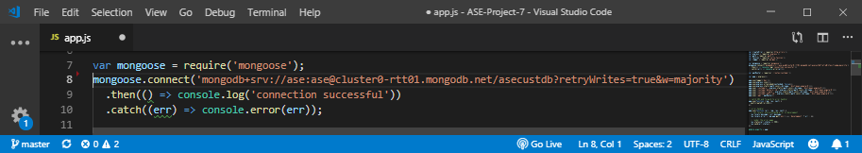**Mongo Database Connection (app.js)**

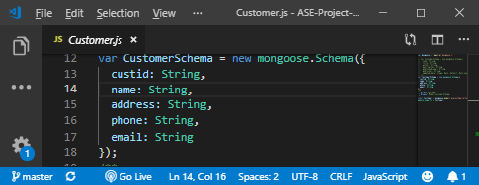**Mongo Schema (Customer.js)**

**Home Page (customer.component.html)**

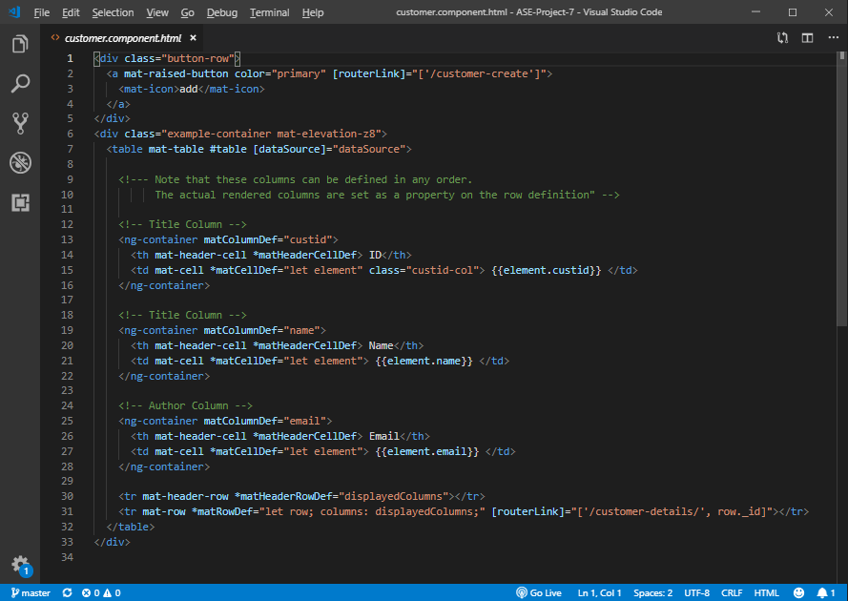

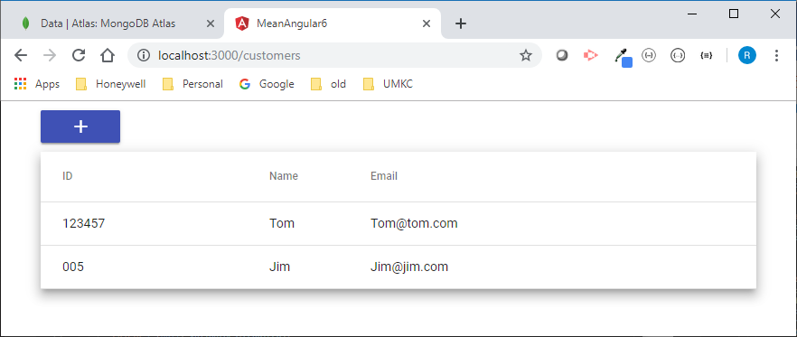

**Home Page TS file (customer.component.ts)**

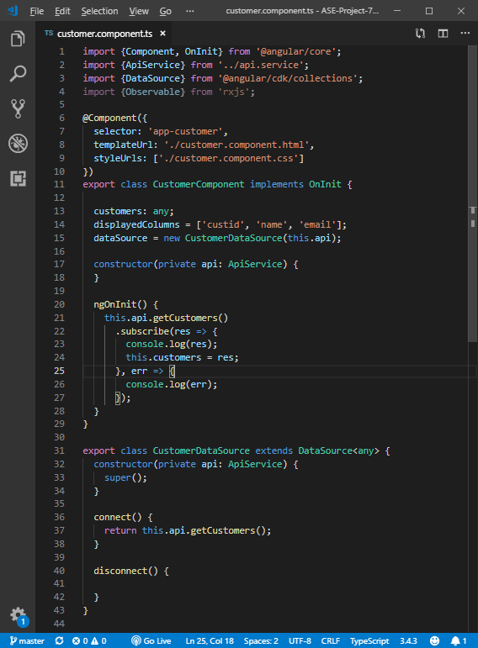

**Create Customer Page (customer-create.component.html)**

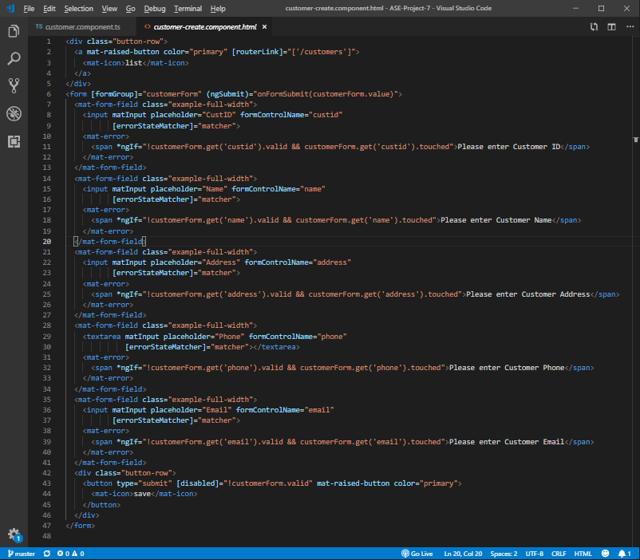

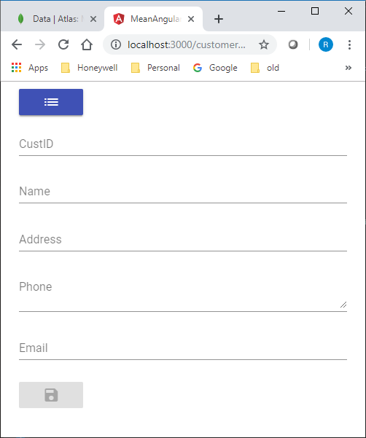

**Create Customer TS Page (customer-create.component.ts)**

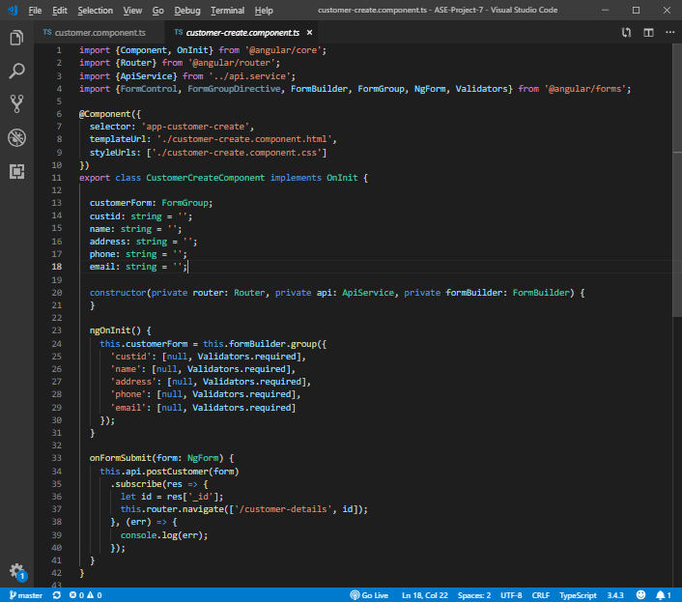

**Customer Details Page (customer-detail.component.html)**

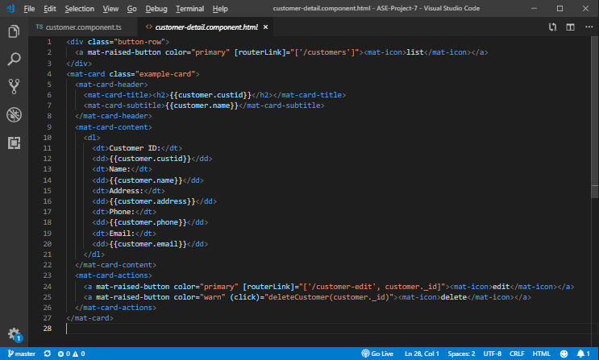

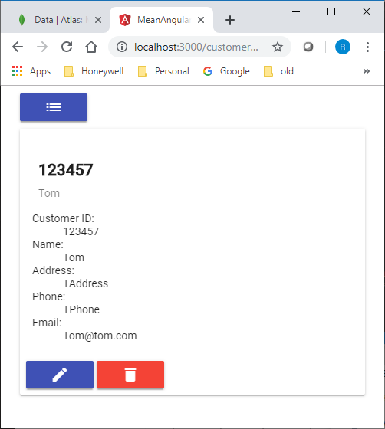

**Customer Details TS Page (customer-detail.component.ts)**

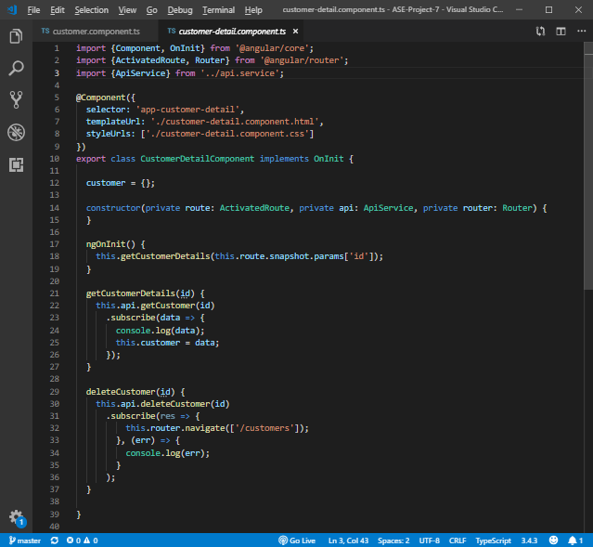

**Customer Edit Page (customer-edit.component.html)**

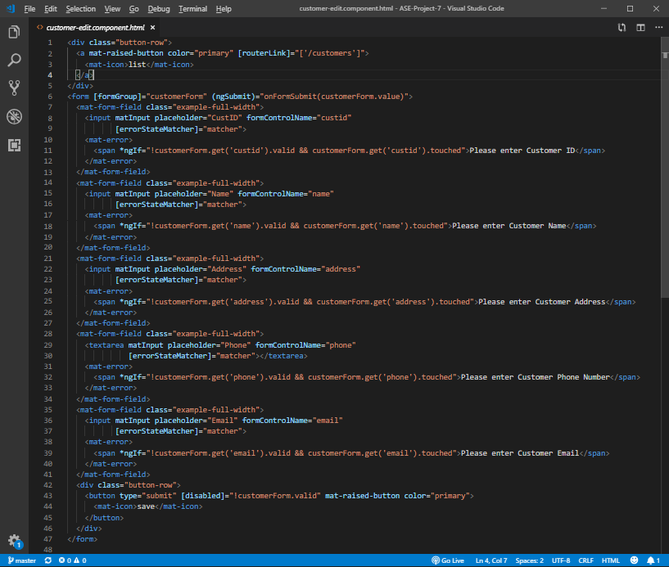

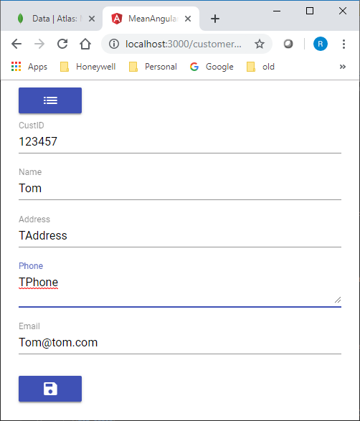

**Customer Edit TS Page (customer-edit.component.ts)**

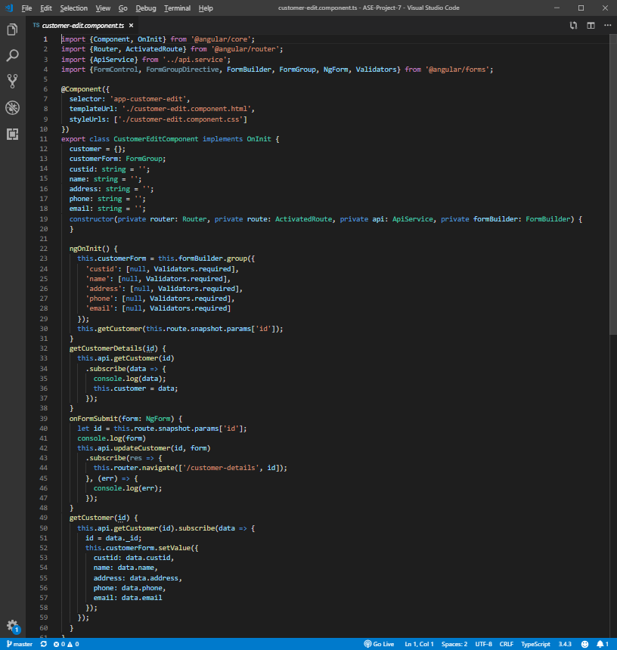

**MongoDB Atlas (MLab) Database**

